1. Environment Setup & JVM Understanding

  - Setup Documentation
Install JDK and configure development environment:
- Download JDK (e.g., OpenJDK or Oracle JDK) for your OS.
- Install using the installer or package manager.
- Set JAVA_HOME to the JDK install path.
- Add JAVA_HOME/bin to PATH.
- Verify installation:
- Cmd > javac –version
- Cmd > java –version
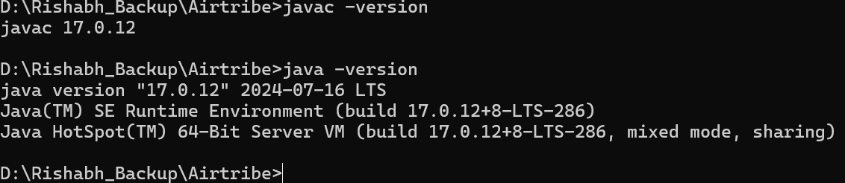
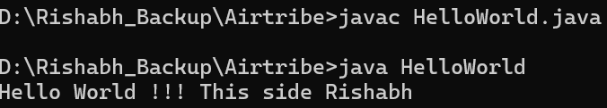
  - JVM Architecture Report
Simplified JVM Architecture
- Class Loader Subsystem: Loads .class files (binary data) into Method Area.
- Runtime Data Areas: Method Area (class metadata), Heap (objects), JVM Stacks (frames for method calls), PC Registers, Native Method Stacks.
- Execution Engine: Interpreter (interprets bytecode), JIT Compiler (compiles hot code paths to native machine code), Garbage Collector (frees unused objects).
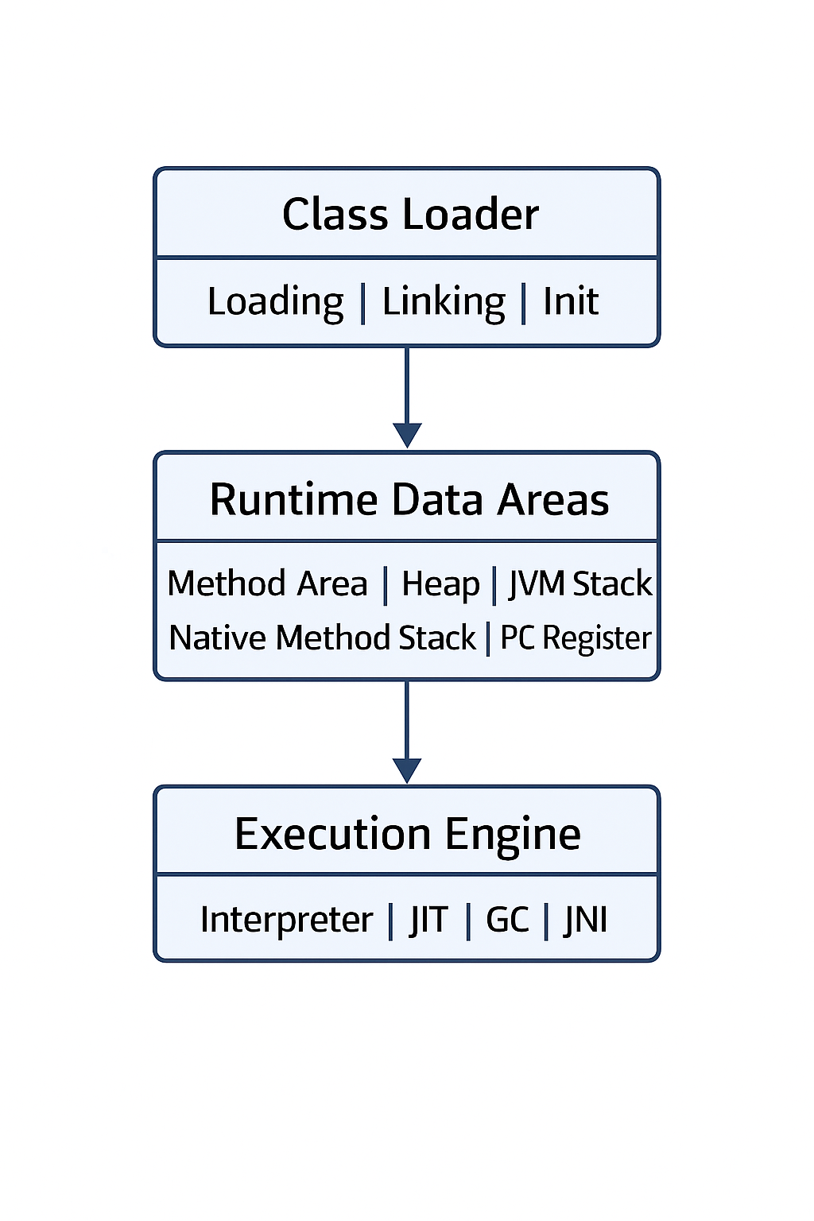
JIT vs Interpreter
- Interpreter reads bytecode instructions and executes them directly (slower start up, simpler).
- JIT compiles frequently executed bytecode into native code at runtime for performance (faster execution after warm-up).
Bytecode Execution Process
- Java source (.java) -> javac -> .class bytecode.
- Class Loader loads class into JVM.
- Bytecode verified, prepared and resolved.
- Execution Engine interprets or JIT-compiles bytecode to native instructions.
Write Once, Run Anywhere
- Java bytecode is platform-independent. The same .class files run on any OS that has a compatible JVM implementation.
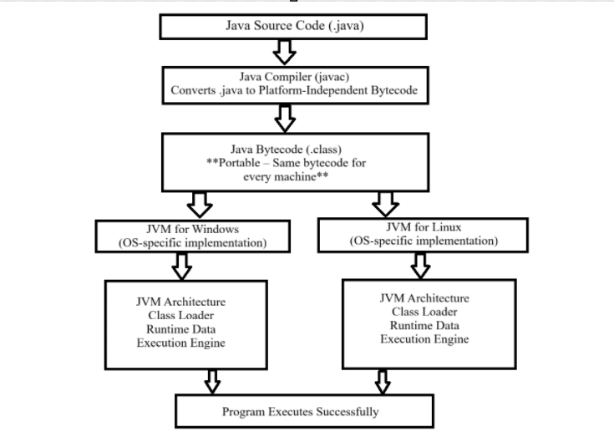

2. Package Structure & Basic Syntax
2.1 Package Organization
Package hierarchy: com.airtripe.studentmanagement with sub packages: entity, service, util, main.
Demonstration of package-private and public access: Utils.appName is package-private (default) and Utils.printHeader is public.
2.2 Data Types & Variables
Primitive data types examples and typecasting scenarios:
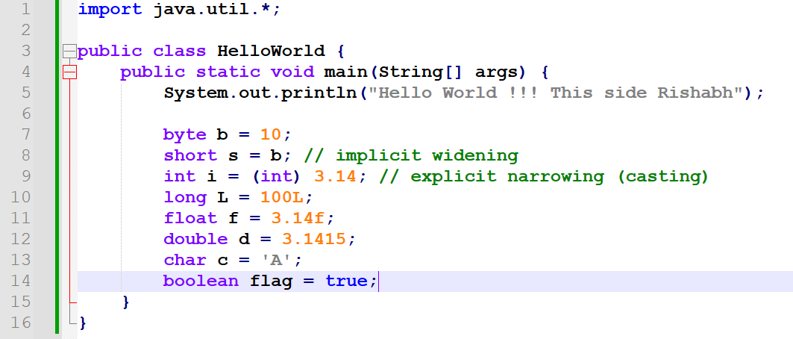
Static vs Instance variables:
static int idCounter in Student demonstrates a class-level (static) variable shared across instances. Instance variables like name and age are per-object.
Demonstrate variable scope (local, instance, static)
Local Variable
- Declared inside a method, constructor, or block
- Scope: only within that method/block
- Memory: inside stack
- Cannot use access modifiers (public, private, etc.)
Global / Instance Variable
- Declared inside a class, outside any method
- Belongs to the object
- Each object gets its own copy
- Memory: inside heap
Static Variable
- Declared using static keyword inside a class
- Shared by all objects
- Loaded when class is loaded
- Memory: Method Area of JVM
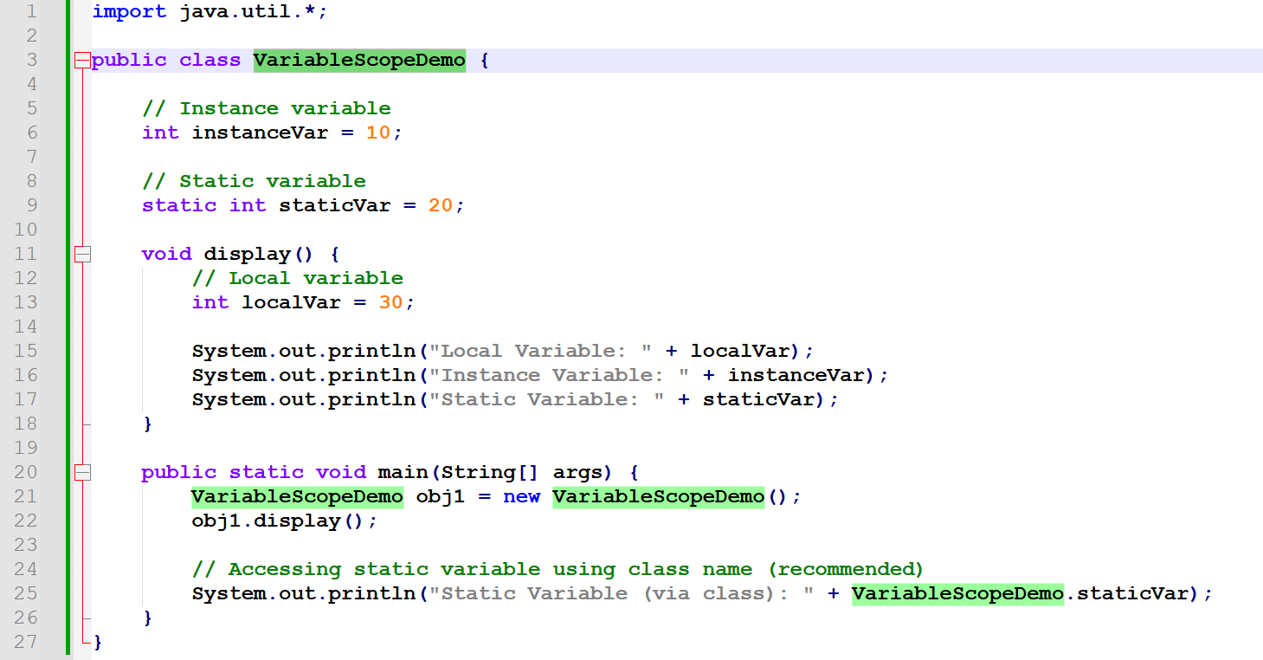
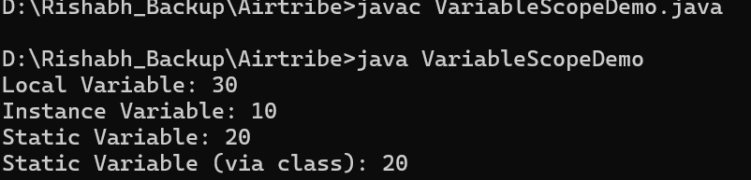

3. Object-Oriented Programming Implementation
3.1 Encapsulation
Student class uses private attributes with public getters/setters to control access.
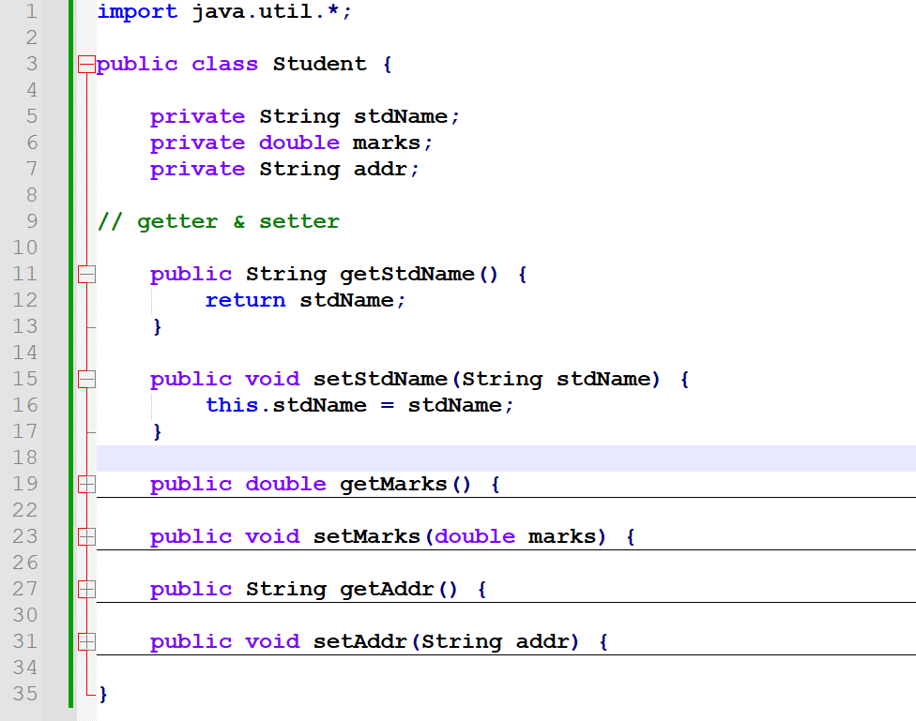
  - Inheritance
- Person = base (parent) class
- Student = derived class extending Person
- GraduateStudent = subclass extending Student

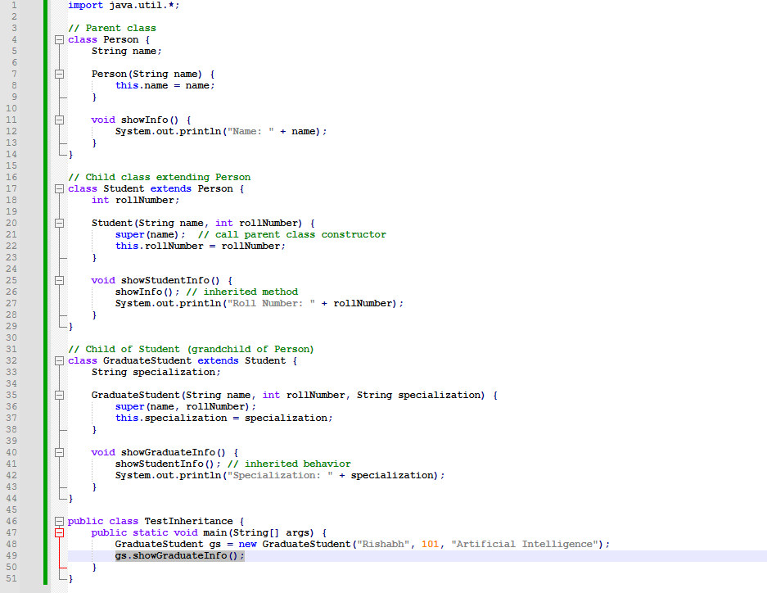
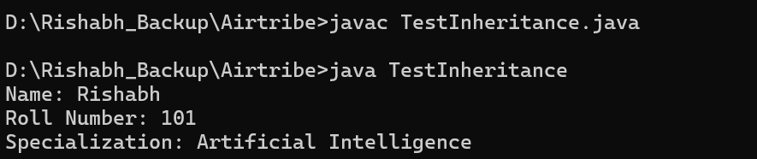
Demonstrate multilevel inheritance with proper constructor chaining
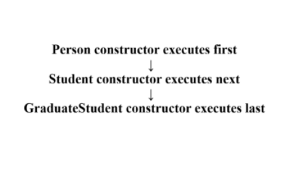
Explain diamond problem and Java's solution
The diamond problem occurs in multiple inheritance when a class inherits from two parent classes that both inherit from the same grandparent class.
This creates ambiguity: which version of the inherited method should the child class use?

- Class B and C inherit from A
- Class D inherits from B and C
- If A has a method show(), and D calls show(), should it use B’s version or C’s version?
class D extends B, C; // ❌ Not allowed in Java
Java’s Solution: Interfaces + Default Methods
Java allows multiple inheritance in terms of interfaces but not classes.
Since Java 8, interfaces can have default methods also, which can cause ambiguity error so Java forces explicitly to resolve it.
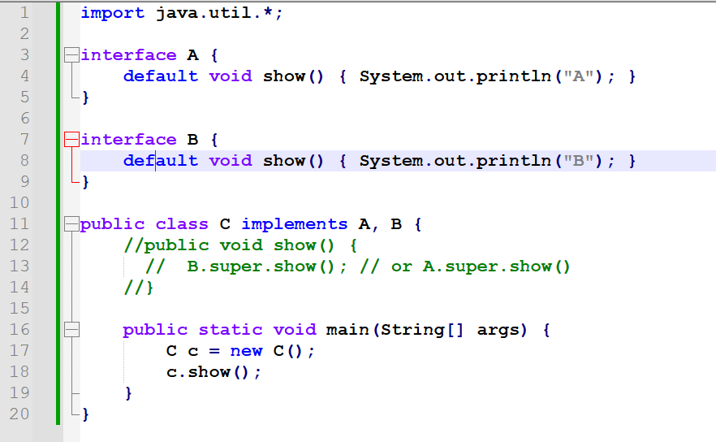
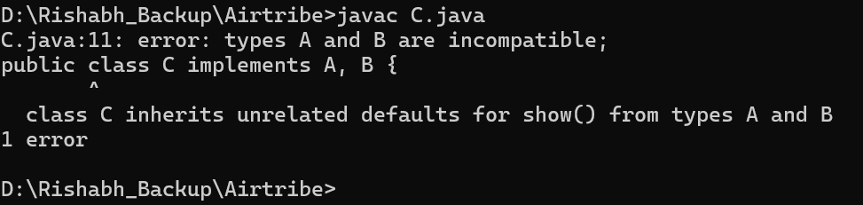
Now, Here the compiler got confused which show() method need to invoke/call’s.
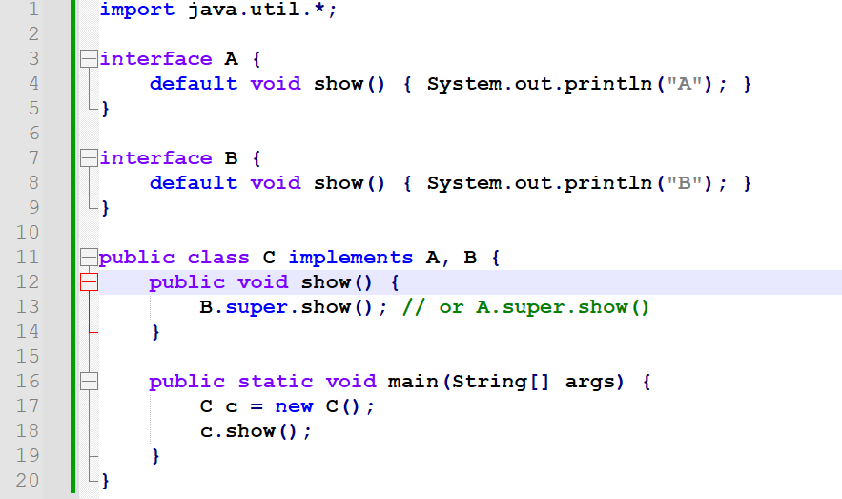
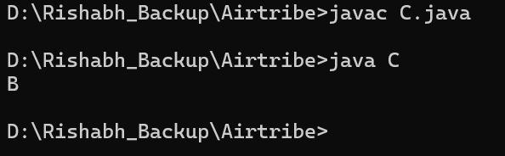
3.3 Polymorphism
Polymorphism means one name with multiple behaviours or one name with multiple format’s or one action in multiple ways.
Implement method overloading (compile-time polymorphism)
Same method name, different parameter lists.
Decided at compile-time based on argument types or number of parameters.
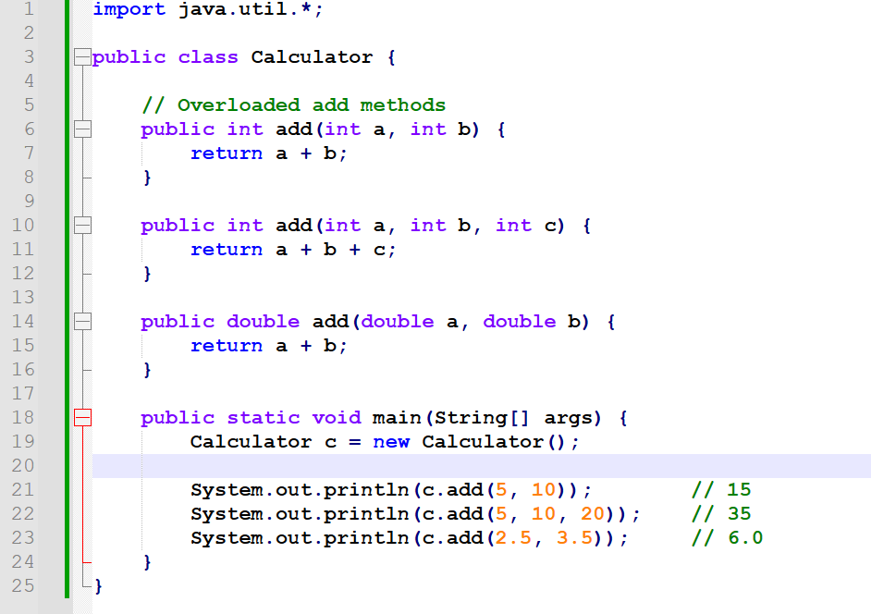
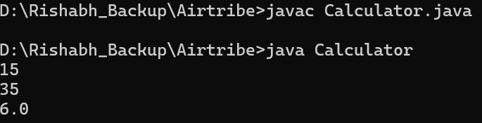
Implement method overriding with @Override annotation
Same method name, same parameters, different class
Occurs in inheritance
Resolved at runtime
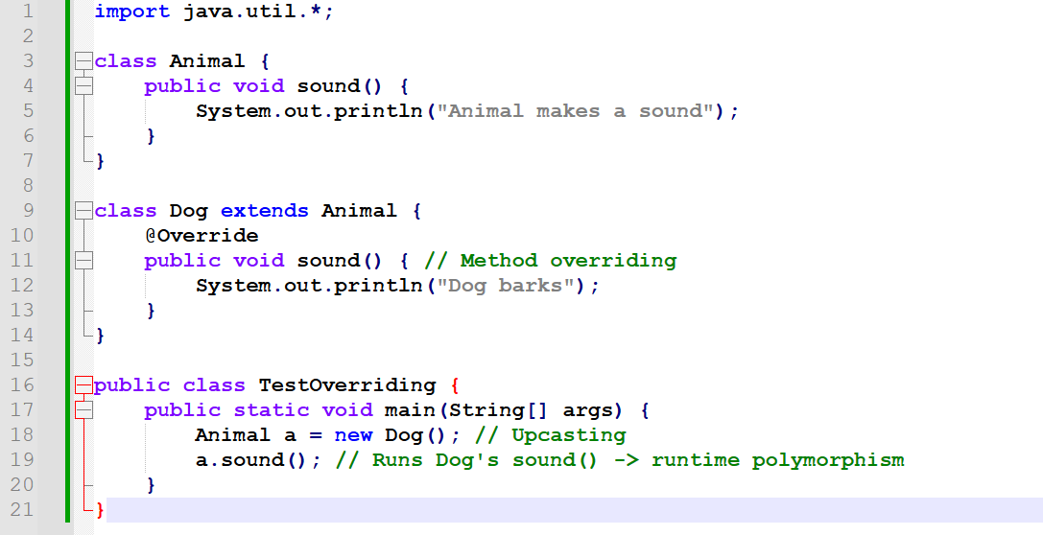
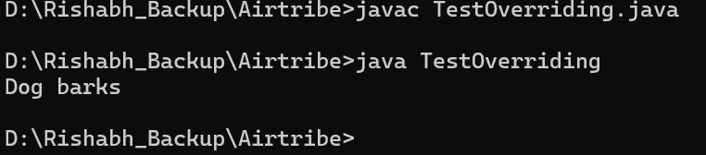
Demonstrate dynamic method dispatch
Dynamic Method Dispatch is the mechanism in Java that enables runtime polymorphism.
It allows the JVM to decide which overridden method to call at runtime based on the runtime object but not on the reference type.
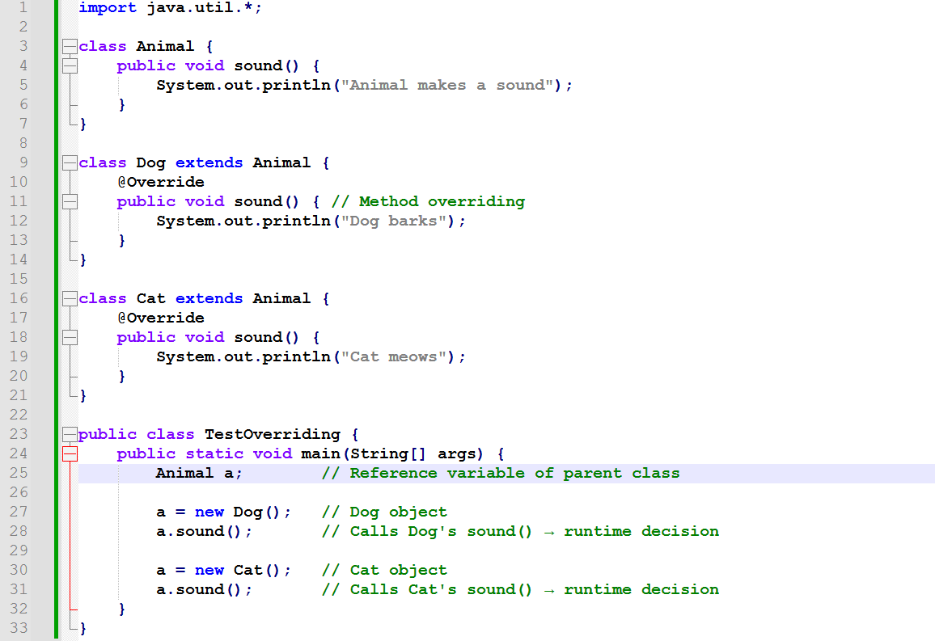
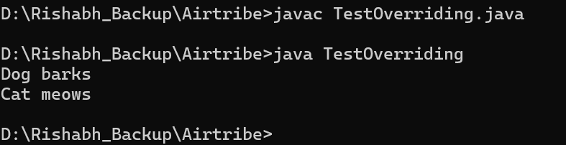
Show runtime polymorphism with base class references
The above example itself referencing the Base class or Parent class reference which is nothing but Animal class.

4. Advanced OOP Concepts
4.1 Abstraction
Create abstract class with abstract methods
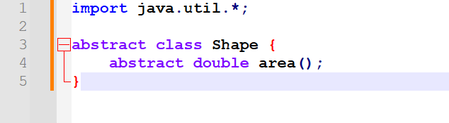
Implement interface with multiple implementations
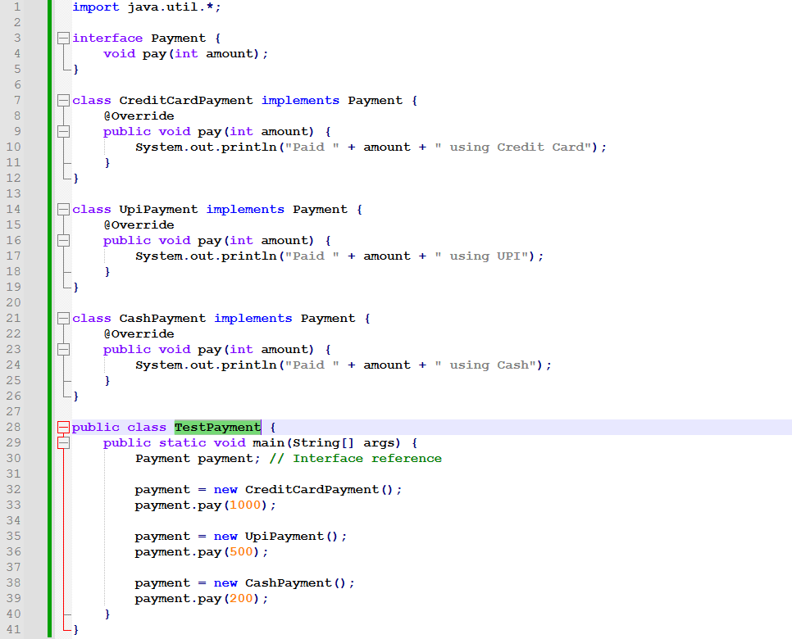
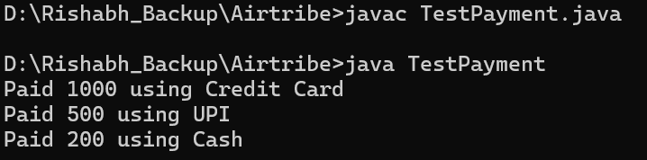
Show difference between abstract classes and interfaces
Interface | Abstract Class
When we do not know anything about implementation just we have requirement specification then we should go for Interface. | When we know little bit about implementation that means we have partial implementation then we should go for Abstract classes.
Interface can only have abstract methods Before Java 8 but from Java 8 it can have Default methods, static methods, abstract methods. | Abstract classes can have any number of abstract and non-abstract methods.
Interface can show 100% pure abstraction Before Java 8 but from Java 8 it act like a contract. | Abstract class not show 100% pure abstraction.
Interface variables by default public static and final. | Abstract class variables can be instance variables, final or non-final.
Interface cannot have constructors. | Abstract class can have constructors.
Interface methods are public by default and from Java 9 it can have private access modifier also. | Abstract class can have any access modifier.
Use default methods in interfaces (Java 8+ feature)
Before Java 8, interfaces could only declare abstract methods.
If a new method was added to an interface, all implementing classes had to override it, breaking existing code.
Default methods allow interfaces to evolve by providing method implementations without breaking existing classes.
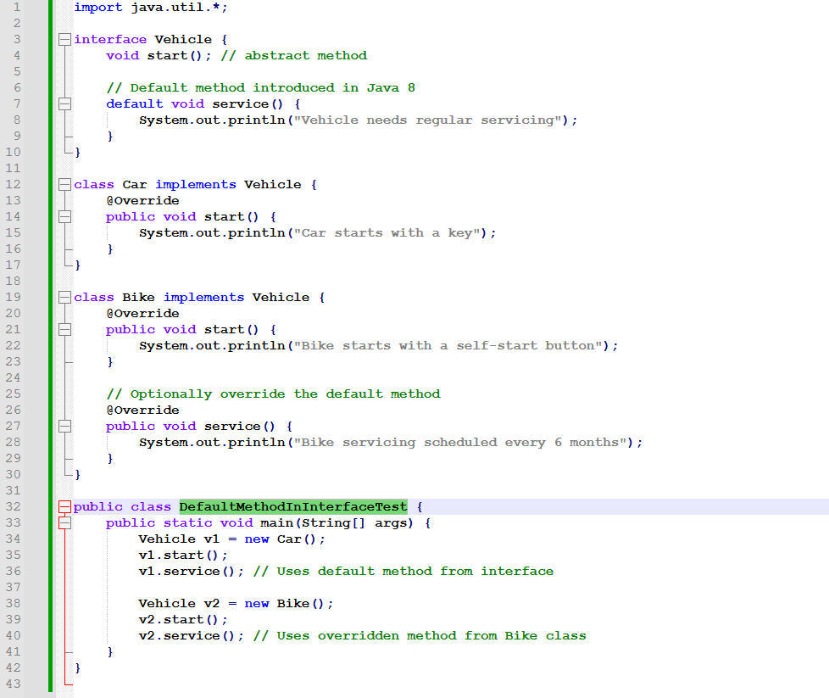
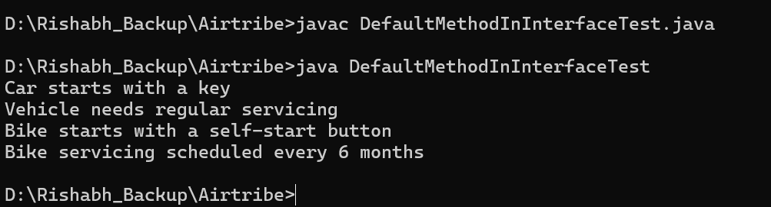
4.2 Constructor Management
Implement default, parameterized, and copy constructors
A constructor is a special method used to initialize an object when it is created.
Default Constructor
A constructor with no parameters. To create an object with default values. Useful when we need a simple object initialization.
If we don't create any constructor, Java provides one automatically.
Parameterized Constructor
A constructor that accepts parameters to initialize objects with custom values. Allows setting different values for different objects. Helps achieve object initialization in a single line.
Copy Constructor
A constructor used to create a new object by copying values of another object. To create a duplicate object with the same state. Useful in cloning, avoiding changes to original objects (immutability support)
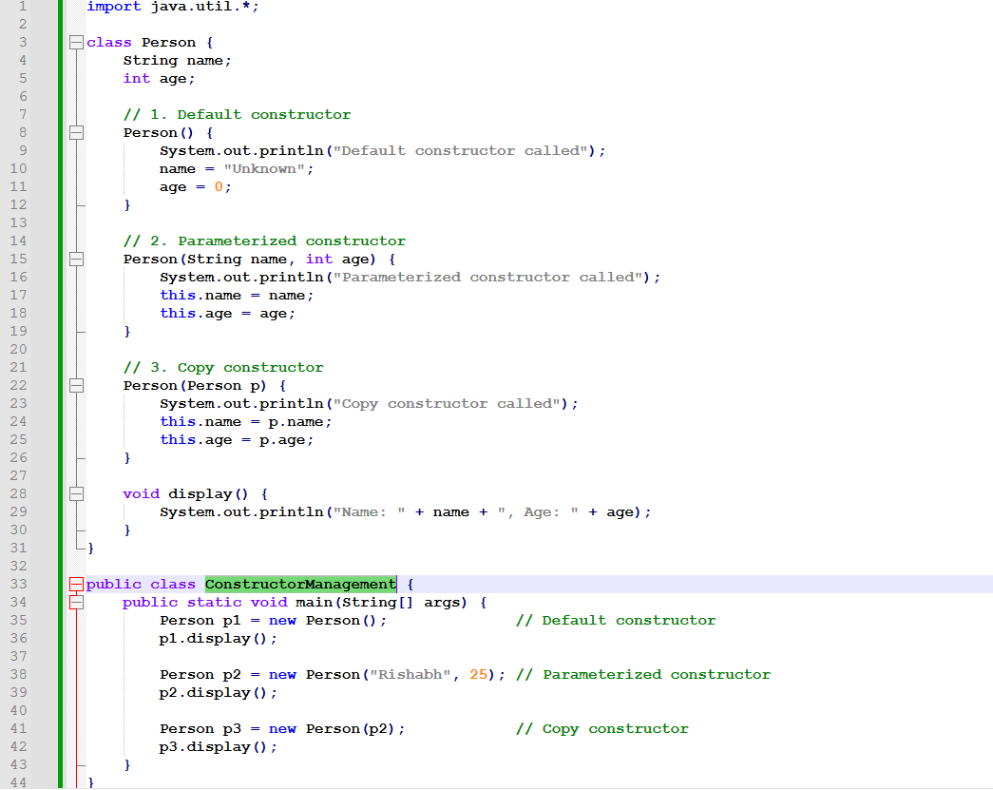
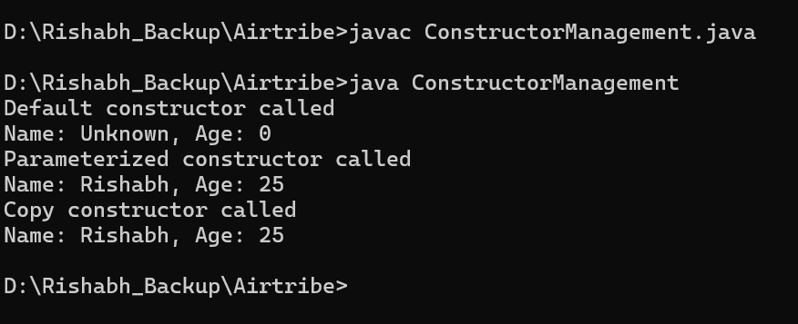
Demonstrate constructor overloading
Constructor overloading means having multiple constructors in the same class with different parameter lists.
Java determines which constructor to invoke at runtime based on the number and type of arguments passed.
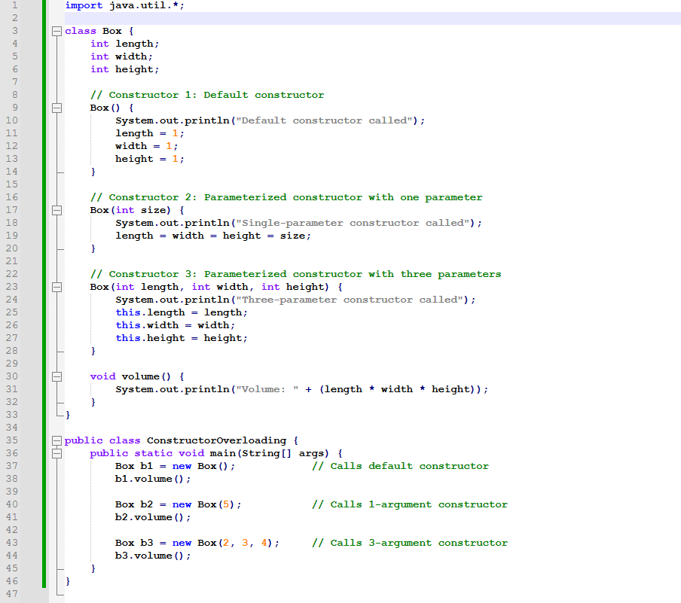
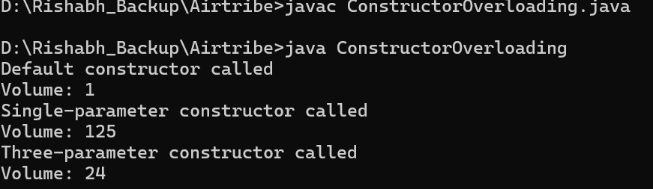

Show constructor chaining using this() and super()
Constructor chaining is the process of calling one constructor from another constructor within the same class (using this()) or in the parent class (using super()).
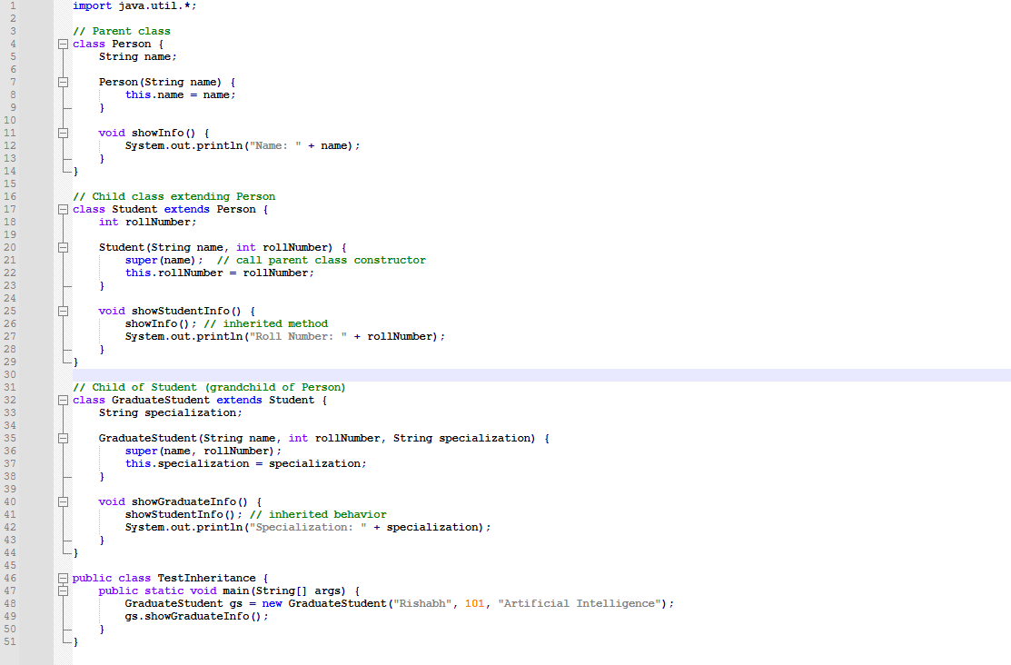
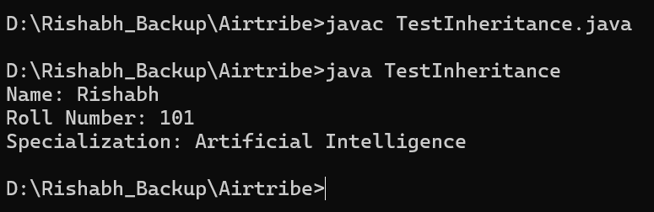
Handle constructor in inheritance hierarchy
- Constructor is not inherited, but constructor chaining happens automatically.
- The constructor of the parent class executes before the child class constructor.
- If we don't explicitly call super(), Java inserts super() automatically.
- We can use super() to call a specific parent class constructor.
- Constructor chaining flows top → bottom in the inheritance tree.
